Abstract
The character of Ariel in Shakespeare’s The Tempest takes many forms over the play, making numerous physical transformations in order to make mischief. In the long production history of the play, the character has been played by actors of all genders, but how is the fluidity of the character represented in the pronouns used in academic writing over the years?

Introduction
In The Tempest the character of Ariel is listed in the dramatis personae as an “airy spirit”. The male pronoun he is used in reference to the character once, but they are far more frequently referred to as “spirit” or by a variety of nicknames including “my bird,” “delicate Ariel”, and often fondly as “my Ariel.” Over the course of the play Ariel takes the form of a sea-nymph, a harpy, and the goddess Ceres. The role has been played by actors of all genders over the years; it originated as a young boy’s part, was largely portrayed by women in the romantic period, and is now played by all genders and sometimes by more than one actor of various genders. There is a strong textual argument to be made that Ariel is not male, or female, or necessarily any gender, but just genderless spirit.

Given the ambiguous text, and the varied production history, I was interested to see how Ariel had been gendered in academic books and articles over time. Tracking pronoun usage for this character in scholarly writing could potentially be a snapshot for how understanding of the text, and of gender, has changed over the years.

Base dataset
The data set was collected from a collection of articles and book chapters found through CUNY OneSearch. Other collections were considered - including JSTOR or MLA. Ultimately, the decision was made to use CUNY OneSearch because it offered the greatest ease of use and access. OneSearch allows the user to filter searches by which texts are fully available through The Graduate Center, where I am a student. Because this project necessitates having access to full texts, this streamlined the data collection process considerably. Given the short time available to complete the project, and the positioning of the project as a teaching-tool rather than a published piece of academic research, this felt like the right position.

However, this choice did limit the data set in several ways. First, CUNY OneSearch is searching metadata and titles, not full texts. This is helpful if you are looking for the most relevant works to your research topic, but for a project using a zoomed-out approach like this one it means that you are potentially missing articles that could have contributed to your dataset. Having fewer articles makes the project more manageable and less time consuming, but it may also be less accurate. Using CUNY OneSearch is also limiting, and biased, because you are only seeing articles that the Graduate Center has full digital access to. Choosing to limit your project to these sources means that your research is already biased by the access decisions made by the university: decisions which may be financial, political, or quality based. A more thorough approach would be to use JSTOR or MLA, and then use Interlibrary Loans to gain access to articles and books not directly available through the Graduate Center. This method would also include works that had not been digitized. It is, however, a vastly more time consuming approach.

My search terms in OneSearch were “The Tempest” + Shakespeare + Ariel. I applied filters limiting the search to articles, books, book chapters, and dissertations where the full text was available online (this also removed results for audio and visual documents). The resulting data set was 104 documents. 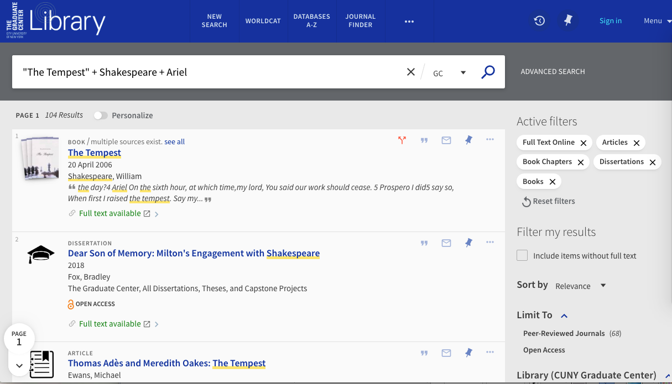

My next step was to download all the articles as PDFs. I had to do this manually, going through the search results and grabbing them one by one. This process was slow and laborious, but it had the benefit of acting as a second round filter. In this stage of the process I caught many articles that were unsuitable for this project (for instance, articles about productions or other interpretations of The Tempest that didn’t discuss the original text), and also a significant number of duplicate entries. I should also note here that I did not catch every unsuitable article during this step in the process, and continued to refine the data set into the next steps. I ended up with a data set that was culled from 104 results to 39 pdf files.

Transform stage 1

I created a simple spreadsheet using Google Docs to compile the information I was pulling out of the articles. This included the article name, author(s) name(s), year of publication, and the pronouns (if any) ascribed to the character Ariel. My method for finding this information was simple, but time and labor intensive. I opened each article, searched the text for the name Ariel, and read as many of the surrounding sentences were still discussing the character to see if there was a pronoun used. If the PDF was not searchable I would skim the entire article. There are likely programming methods that would have made this process go faster and easier, but there were some advantages to my method. The first is that it served my programming skill level, and demonstrates that having an advanced technical education is not always necessary for doing digital projects. The second is that it allowed this step to act as another point in which the documents were being checked for relevance. The third is that manually reading through the articles gave me a sense of the context in which Ariel was being discussed; something that eventually influenced the direction of the project.

The results of this stage were initially disappointing. Of the thirty-nine articles, book chapters, and dissertations, only two used gender neutral pronouns for the character. Ten never used a pronoun for Ariel. The other twenty-seven all used the male pronouns he/his.
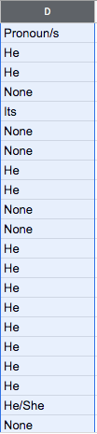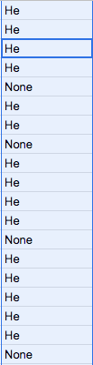

I will admit that I had hoped for some kind of trend towards gender-neutral pronouns as time went on. As far as this data showed, the two instances of neutral pronoun use were in 2007 and 2014; both fairly recent but too isolated and scattered to predict any kind of trend.

Transform stage 2
What I did notice while I was looking for pronoun use was that some articles would specifically discuss Ariel’s gender-ambiguity in the text or performance history, and then still use male pronouns. This raised interesting questions about how likely the habits or conventions of scholarship are to change even as our ideas about constructions like gender are in constant states of flux. I went back into the articles and added a new column to my spreadsheet documenting whether Ariel’s gender or gender presentation was discussed in any way. I debated whether or not to present this information as a binary (Discussion/No Discussion), but I ultimately decided to give a brief descriptive note or quote when there was some discussion of gender, because I wanted to depict the many forms that discussion took. This decision likely derived from my background in academic work, in which I have not historically used much data. This approach was more akin to note-taking than it was to preparing data, and it ended up needed to be revised when it was time to create visualizations. In the future I would have one column that noted whether there was any discussion of gender, and an additional column to make any notes that I might find interesting. 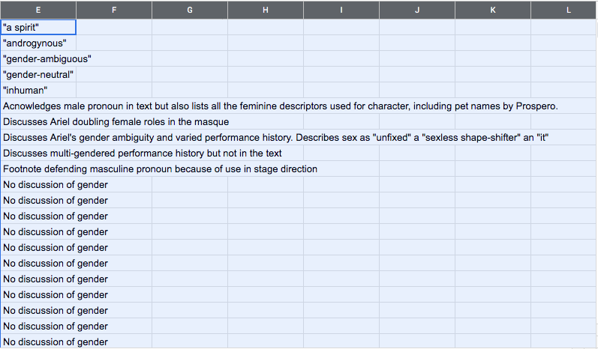

Prepped for analysis
I decided to make a series of simple charts to visualize the data in order to make what I found interesting about it more easily recognizable. I, with some embarrassing slowness, realized that I was going to have to completely restructure my data in order to make it legible for charts. This is what my original spreadsheet looked like:

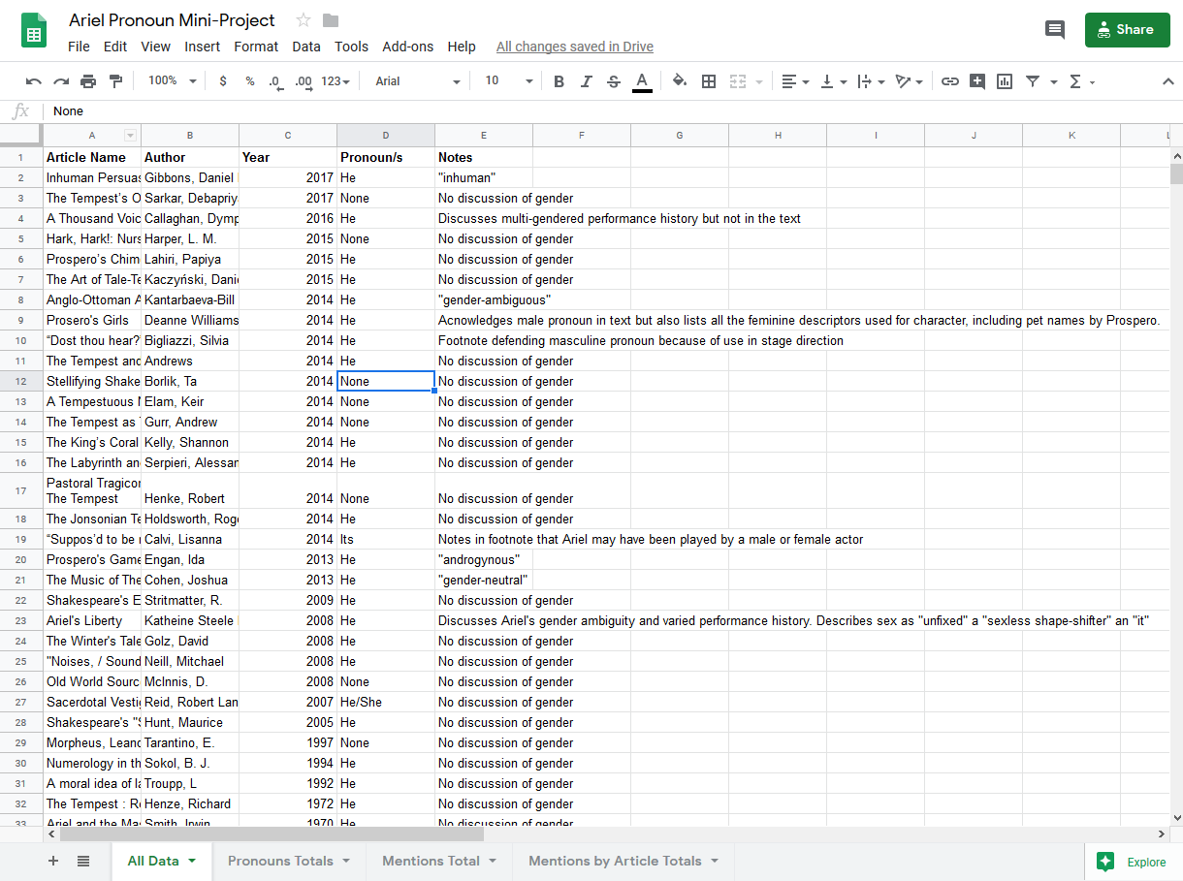

As I commented on earlier, this was great for my own personal note-taking, but isn’t legible to a computer to make a chart from. A friend helped me structure and break out my data (friends and search engines are invaluable resources!) This is the spreadsheet I ended up with for making my first two charts:
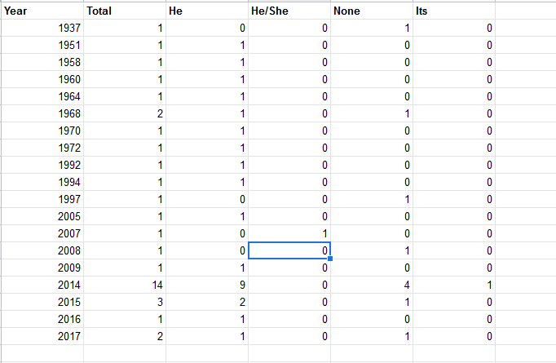

First, a chart showing the number of articles I was able to gather for every year. The huge spike in 2014 is significantly, although not entirely, due to several of the articles that I gathered being taken from one book published that year. I chose to include them as separate texts because they didn’t share an author. They do, however, share an editor, which could mean that there were stylebook rules in place for the pronouns being used for Ariel. However, the chapters I collected are not homogeneous in their pronoun use, and in fact include one of the two uses of a gender neutral pronoun. While this results in a comically proportioned graph, you can see from the second graph (below) that it did not cause any trends to be misrepresented, as the male pronouns are still significantly more represented in that year, followed by no pronoun use, and with one instance of a gender neutral pronoun.
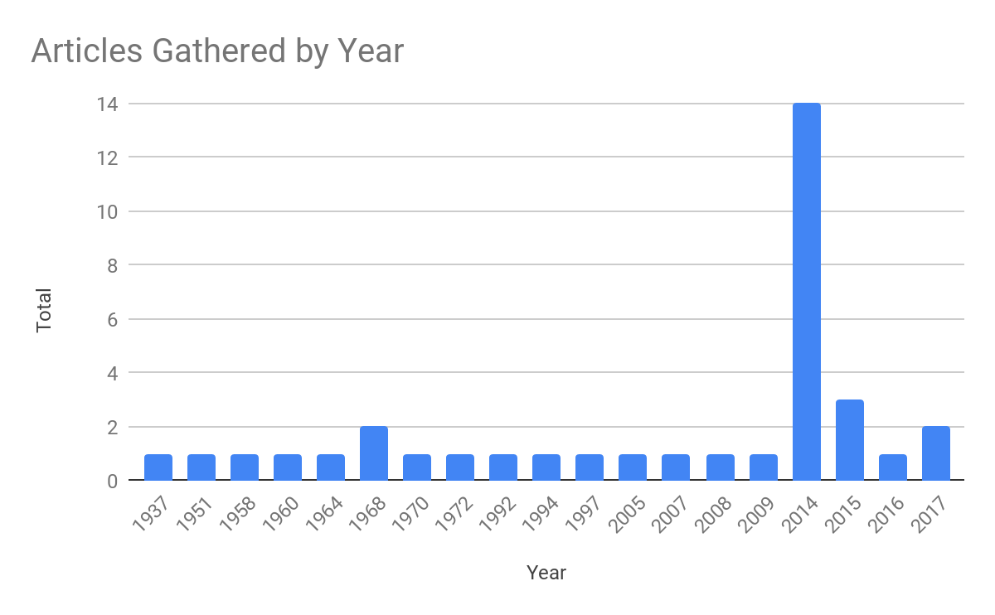
Next, A chart showing pronoun use over time.

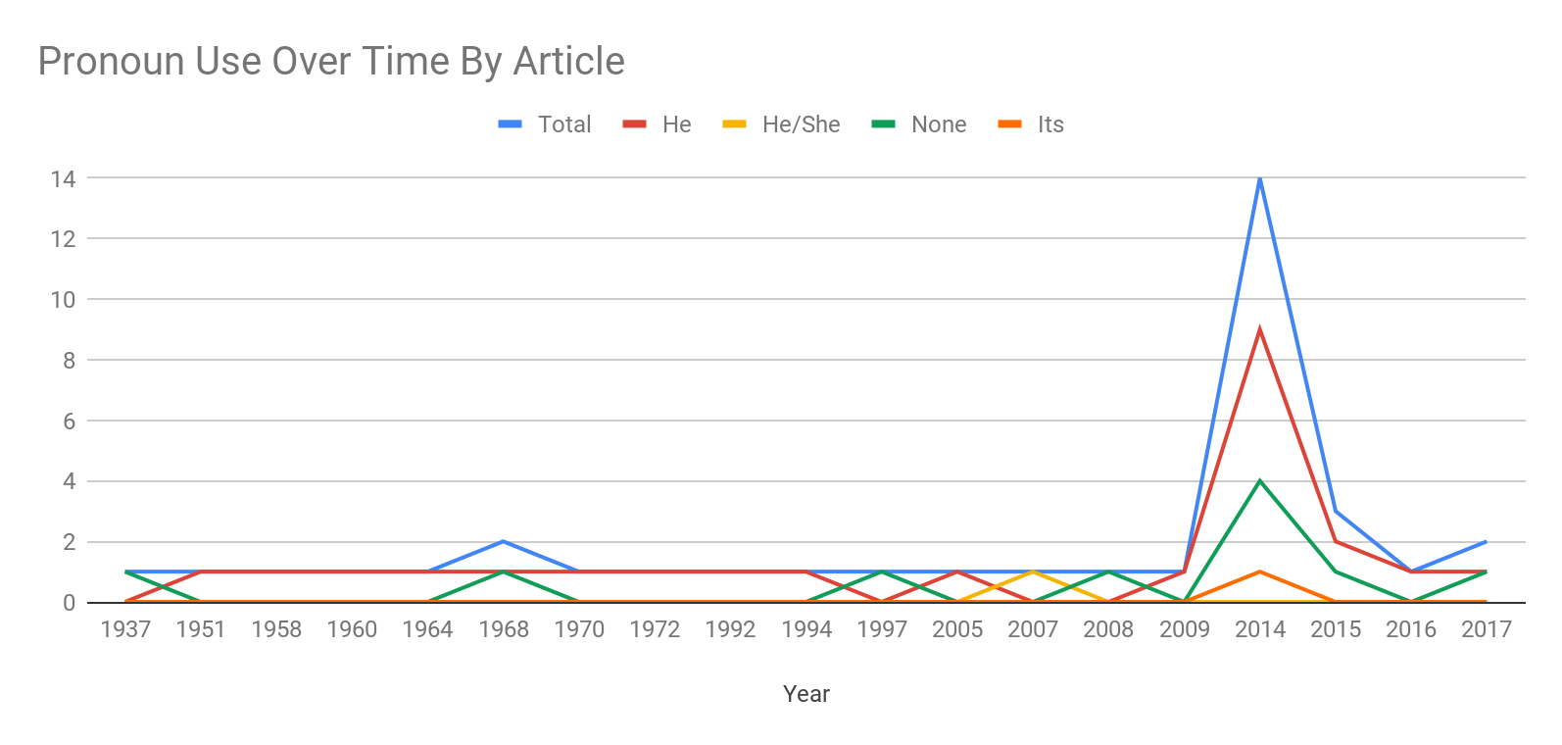

Then, I wanted to visualize how many articles had any discussion of Ariel’s gender over time. Here is the spreadsheet I used to make that chart:

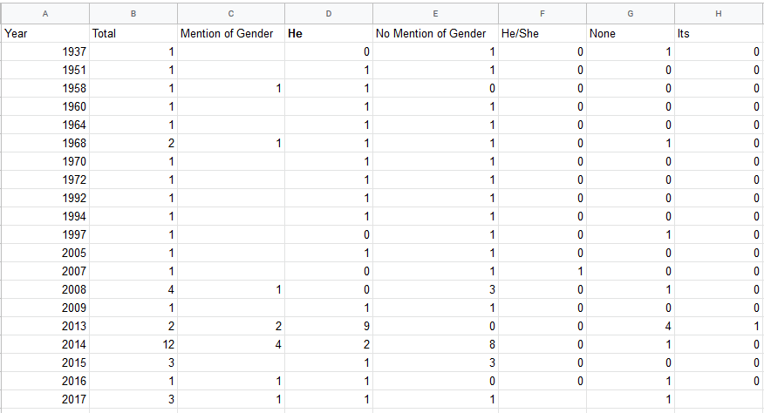

And here is the resulting chart. It can be seen clearly here that Ariel’s gender is being discussed increasingly as the years go on, albeit still inconsistently. You will notice I ended up not using a significant number of the columns on that chart. This is because there were so few articles that discussed Ariel’s gender that when those other categories were included, that information became overwhelmed by all the other data and difficult to read. Instead I added an additional chart at the end.

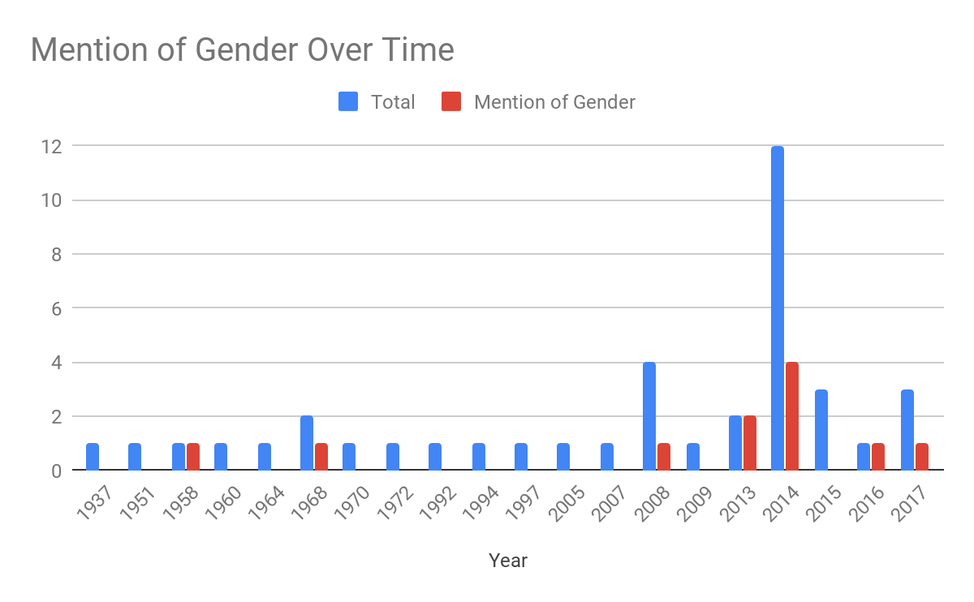
Finally, I made this table, which shows how many of the articles that discussed Ariel’s gender and fluidity still used male pronouns. I originally made this into a chart, but felt that the data was more accurately visualized in the bareness of the numbers.

Articles Including Gender Discussion: 11
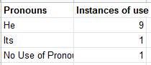

Analysis

This project is a good example of many aspects of data work: why larger data-sets give you more interesting results (I would love to compare these findings to a more thorough analysis of production and art history), how data work can be done with minimal to no programming skills, and how charts without explanations can be misleading, amongst other things. The thing that I am most hopeful that it can serve as a representation of, however, is how data that may initially disappoint you may ultimately still lead to something interesting. I went into this project hoping to see a more varied data set; maybe one that mimicked the production history of the character. I was annoyed when my guess was proven to be incorrect. However, it was the process of gathering and transforming the data that lead me to observe how even articles acknowledging the fluid gender presentation and identity of the Ariel character continued to use male pronouns. This is the humanistic part of digital humanities data work. Data is not an objective literal substance the way a certain rock is marble. It is shaped by our observation, our attention, and our questions. It is a sculpture. A relief. A representation.

